Seradex DBOX OpenVPN Connection Information
When we install DBOX, to make our web server able to communicate with your SQL Server we install a VPN client. This VPN client connects to an OpenVPN Access Server we have hosted in Amazon Web Services.
This OpenVPN Access Server is a Linux server, it is protected by requiring a PEM certificate and password to be able to access it, and I am the only individual in the company who has the PEM certificate and password required, now that I’ve realized that, I’m actually going to also give that information to our IT just in case, so it would be me and two others.
Access to the OpenVPN Access Server is also restricted based on the network of the user trying to access the machine, no one can SSH into it without being on the Seradex network.
Multiple of our customer’s machines are connected to this same OpenVPN Server, however I have disabled access between users on the VPN clients.
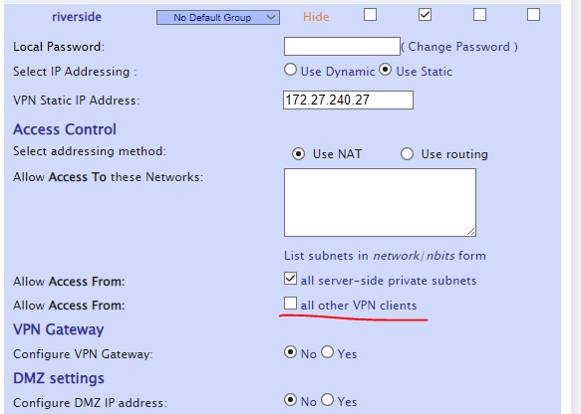
You will notice the “Allow Access From all server-side private subnets” is enabled. What this does is allow our Windows Server, which is on the same private network as the OpenVPN Access Server in Amazon to see your machine (via routing the traffic destined to your SQL Server first to this OpenVPN Access Server).
A few developers have access to the (Windows) Web Server. Through the Web Server it seems that we ARE able to remote into your SQL Server, not just communicate with SQL, I will provide a firewall rule later in this document so that you can block that without breaking DBOX. This machine also is only accessible from within our network. The password to access it is I believe 20 characters so even if someone were to get into our network it’s unlikely that they would find a way to gain access to said machine, and they’d probably focus more on what they can see on our network, not Amazon.
However, even if you block RDP, the website still has access to your SQL Server, which means so long as we know the SQL username and password the website uses, the Windows machine itself has access to your SQL Server through SQL Server Management Studio. I don’t know if there’s really anything we can do about that, anyone who has access to the admin account on that Web Server (which is about 5 people if I’m correct) would be able to find the SQL Username and Password the website is configured to use.

Block Seradex Access VIA RDP
To block our access via RDP you can create an Inbound Rule that blocks UDP 3389 and a second rule that blocks TCP 3389 both of which are destined for your local address of 172.27.240.27. That IP is the static IP we have assigned your SQL Server on our VPN, so these rules would block any RDP traffic coming through the VPN tunnel.
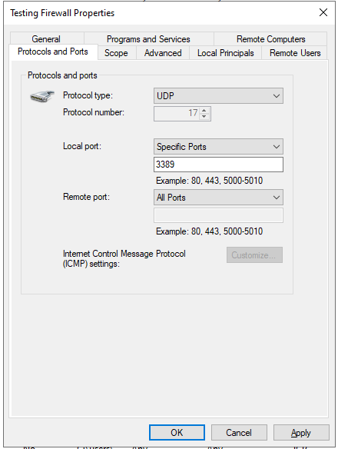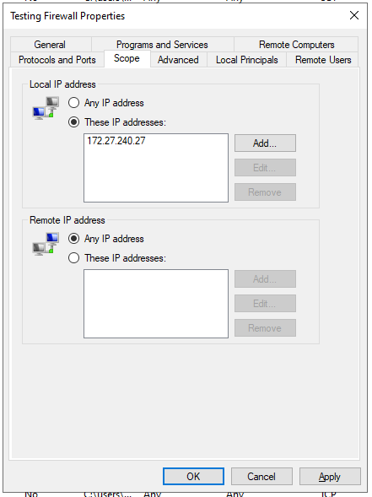
We could investigate more strict firewall rules if desired, however I’m not 100% sure how closed off we can go before it causes issues. I know the OpenVPN client connects through a random port, so it might not be possible to do something as simple as block all communication aside from SQL (port 1433) as it might block the connection altogether.
Let me know if you have any further questions.
- Dylan

